Manchester Encoding Visualization Tool

1. Overview
The Manchester Encoding Visualization Tool is a Java-based application designed to demonstrate Manchester encoding through a graphical user interface (GUI). This tool allows users to load binary data from a file or enter it manually, and visualizes the encoded signal as a waveform.

2. Purpose
Manchester encoding is a line coding scheme used to encode data onto a physical medium. It ensures a transition occurs in the middle of each bit period, which provides synchronization and error detection benefits. This application serves as an educational tool to visualize and understand this encoding scheme.

3. Key Features
- File Reading: Load binary data from text files.
- Manual Input: Enter binary data directly into the application.
- Graphical Representation: Visualize Manchester encoded signals with clear distinctions between 1 and 0 states.
- User-Friendly Interface: Modern design with interactive components for ease of use.

4. Components and Design

4.1. User Interface
- JFrame: Main window that houses the entire application.
- JPanel: Various panels are used for organizing UI components:
  - userInput1: Contains buttons and text fields for user input.
  - userInput2: A placeholder for spacing.
  - userTotal: Combines userInput1 and userInput2.
  - userData: Displays data and results.
  - graphPanel: Displays the Manchester encoded waveform.
- JButton:
  - btnFile: Opens a file chooser dialog to load binary data from a file.
  - btnBinary: Generates the Manchester encoded signal from manually entered binary data.
- JTextField: txtBinary allows manual input of binary data.
- JLabel:
  - binaryLabel: Prompts the user to enter binary data.
  - dataLabel: Displays the binary data and the encoded signal.
- JScrollPane:
  - dataScroll: Scrolls through the textual data.
  - graphScroll: Scrolls through the graphical representation of the encoded signal.

4.2. Color Scheme and Fonts
- Colors:
  - Primary button color: #007BFF (Blue)
  - Button hover color: #0056b3 (Darker blue)
  - Text color: #333333 (Dark gray)
  - Graph line colors: Blue for 1 and Orange for 0
  - Graph background: #F5F5F5 (Light gray)
- Fonts:
  - General text: Segoe UI, size 12
  - Data label: Segoe UI Bold, size 18

5. Functionality

5.1. File Reading
- getStringData(): Opens a file chooser dialog, reads the selected text file, and processes the data to generate Manchester encoded signals. Converts byte data to binary format and updates the UI accordingly.

5.2. Binary Data Handling
- actionPerformed(ActionEvent e): Handles button clicks:
  - btnFile: Triggers file reading and graph drawing.
  - btnBinary: Validates and processes manually entered binary data, then updates the graphical display.

5.3. Graphical Representation
- drawGraph(): Creates and adds a JPanel that contains the graphical representation of the Manchester encoded signal. Uses the GetGraph inner class for custom drawing.
- GetGraph Class: Extends JPanel to handle custom painting of the Manchester encoded waveform. Draws lines and transitions to represent binary data.

6. Code Breakdown
- Component Initialization: Sets up the GUI components, applies styles, and organizes them within panels.
- Event Handling: Manages user interactions and updates the display based on file input or manual entry.
- Graph Drawing: Implements custom painting logic to visualize Manchester encoding.

7. Challenges and Solutions
- Challenge: Handling different data sizes and ensuring the graph scales correctly.
  - Solution: Dynamically calculates graph width based on data length and uses scroll panes to manage large visualizations.
- Challenge: Ensuring user input is valid and providing clear error messages.
  - Solution: Implements validation checks for binary data and file reading, displaying appropriate error dialogs.

8. Future Enhancements
- Enhanced Visualization: Improve the graphical representation with additional features like zooming or panning.
- Extended File Support: Allow other file formats or data types.
- Interactive Features: Add interactive elements to the graph, such as tooltips or click events.

9. output of the programe

1. Convert input binary data to Manchester signal

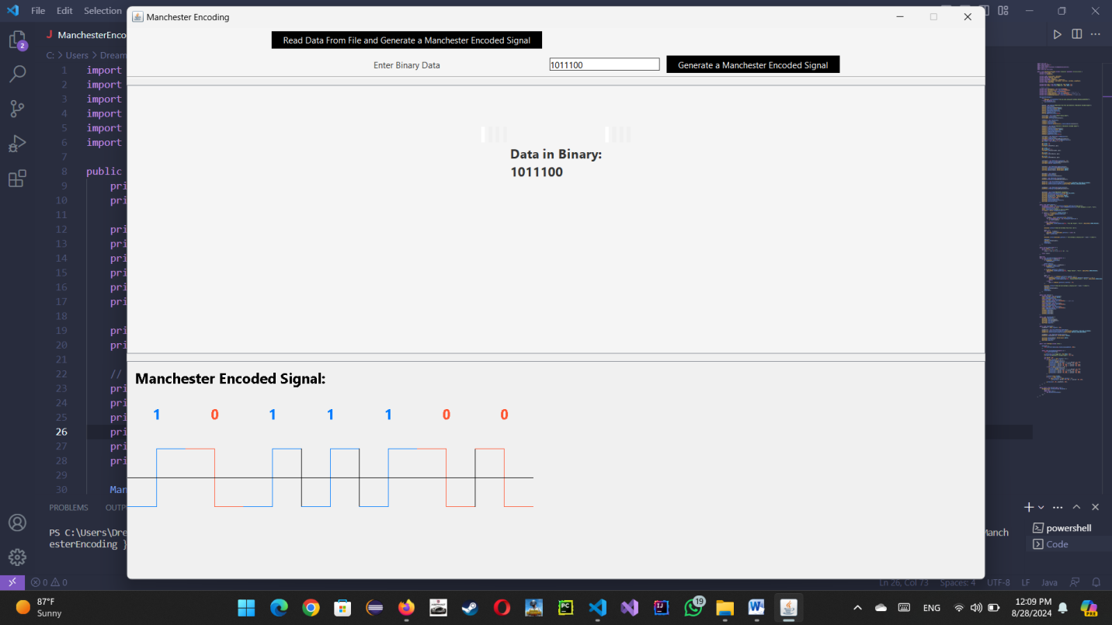

2.choose file as input and convert all data in this file to Binary

.choose file

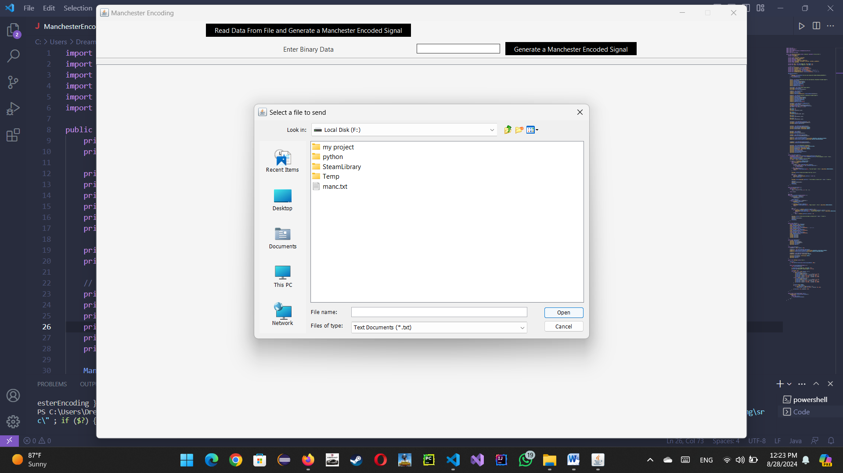

.Select the file then convert all data (any char in the text file) in this file to binary data and then convert to Manchester signal

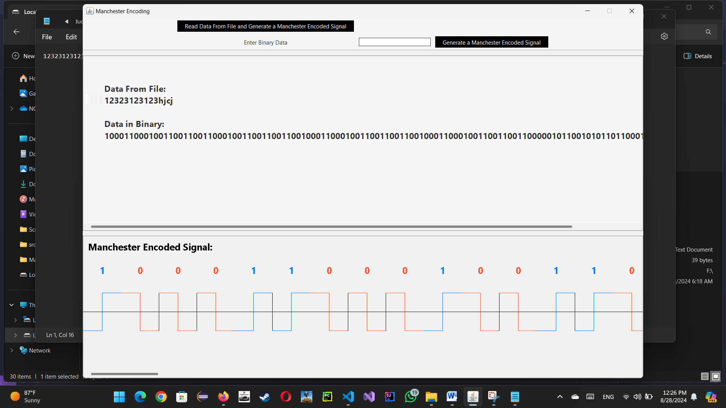

10. Conclusion
The Manchester Encoding Visualization Tool provides a comprehensive and interactive way to understand Manchester encoding. Through its graphical interface, users can load binary data, manually enter data, and view a visual representation of the encoding scheme, making it a valuable tool for learning and demonstration purposes.

